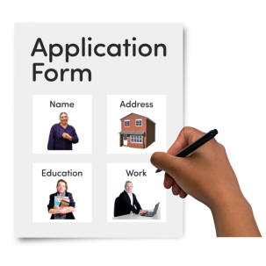 | Job Application Form
 | About You
 | What is your name?
 | What is your address?
 | What is your phone number?
 | What is your email address?
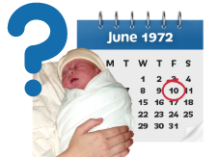 | What is your date of birth?

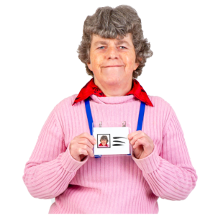 | About Your Experience
Have you had a job before?

Draw a circle around your answer
 |  | Yes |  | No
 | What did you do?
 | Why do you want to do this job?

What skills do you have to help you do this job?

Draw a circle around your answers
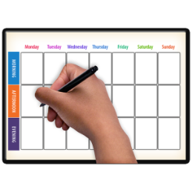 | 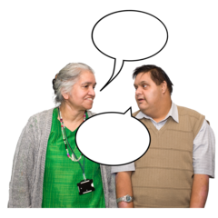 |  |  |  | 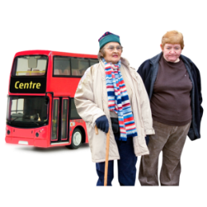
I am organised | I am good at talking to people |  | I arrive places on time |  | I can travel by myself
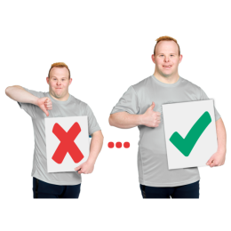
I want to make things better for people |  | I am good at speaking in front of a group |  | I am good at supporting people to do things
 | What other things are you good at?
 | Is there anything else you want to tell us?

