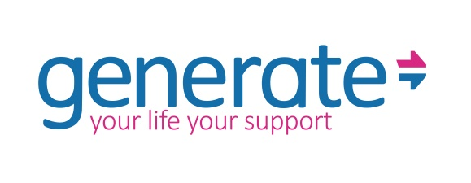

PERSON SPECIFICATION – Generate Advocacy Coordinator
Dear Candidate,

In no more than 200 words per section, please complete the person specification below to demonstrate how you meet each of the criteria for this role.

Please draw on your skills, knowledge, experience and personal attributes and use practical examples where applicable.

Please return this form to us in the original Microsoft Word version – not PDF. Handwritten documents will not be accepted.

How do you meet the requirements regarding the following.
Tell us about your experience supporting people with learning disabilities and neurodiverse people advocate for themselves to have their voice and opinions heard.
To be completed by Generate
Tell us about your experience of working alongside and collaborating with a colleague with lived experience.
To be completed by Generate
Tell us about the last time you created information in accessible formats. How did you proceed?
To be completed by Generate
What experience do you have of planning and delivering user led forums, off-line and online sessions, and outings?
To be completed by Generate
Give us some examples of lobbying or campaigns you have worked on.
What change did they bring?
To be completed by Generate
What is your experience using social media and with WordPress?
Feel free to share links to work you contributed to.
To be completed by Generate
What is your understanding of safeguarding in the context of advocacy and working with adults?
To be completed by Generate
Please tell us about your experience of managing small to medium size budgets in a work/ volunteer capacity.
To be completed by Generate
Give us one example of a time you had to develop and maintain partnerships with stakeholders (e.g. local authority, health organisations and other advocacy groups).
How did you proceed?
What were the benefits and outcomes for your project?
To be completed by Generate

Charity: 1069548 Company: 3461665

